24.63: a) Reducing the furthest right leg yields 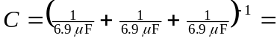 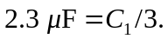 It combines in parallel with a So the next reduction is the same as the first: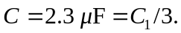And the next is the same as the second, leaving 3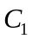’s in series so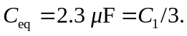
b) For the three capacitors nearest points a and b:
and
c) 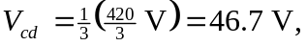since by symmetry the total voltage drop over the equivalent capacitance of the part of the circuit from the junctions between 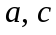 and 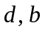 is 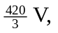 and the equivalent capacitance is that of three equal capacitors in series. 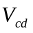 is the voltage over just one of those capacitors, i.e., 